Activity 109
Modal verb for Ability - CAN
The Brothers Bloom

- Ask a partner if he/she can do the following activities.
Model:
S1: Can you...?
S2: Yes, I can / No, I can't

1.Play a musical instrument?
2. Practice karate?
3.Turn sommersaults?
4. Skate?
5. Play badminton?
6. Play table tennis?
7. Juggle with balls?
8. Juggle with chainsaws?
9. Jet ski?
10. Mix music at parties?
11. Make origami?
12. Speak Chinese?
B. Now watch the movie segment and write sentences about the main characters. Use the activities in the previous exercise and use can or can't. She sees people doing what she likes, so she buys books and learns how to do it. What can and can't she do now?
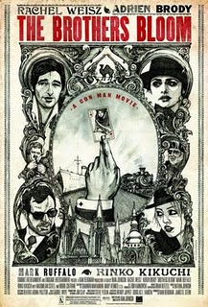
1. Ex. She can play the piano, the violin, the harmonica, the guitar and the banjo.
2.

3.

4.

5.

6.

7.

8.

9.

10.

11.

12.

C. Ask your partner the questions in exercise B.

Ex:

A: Can she play a musical instrument?

B: Yes, she can.

Movie Segments to Assess Grammar Goals
Teacher’s Key – Activity 85 – Short Answers
Yes Man
A.

- Yes, they do.
- No, he isn’t.
- Yes, he is.
- Yes, it does.
- Yes, he did.
- No, he didn’t.
- Yes, there is.
- No, they can’t.
- Yes, they can.
- Yes, he does.
- No, he isn’t.
- No, he doesn’t.
- Yes, he did.
- Yes, he did.
- Yes, they are.
- Yes, I do or No, I don’t.

B.
Questions will vary.

